1. 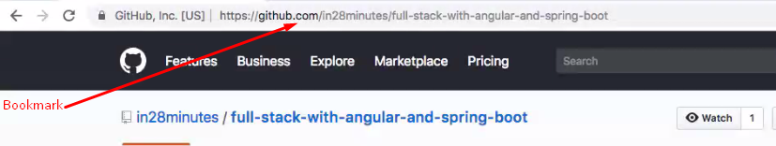
2. 
3. This link contains the links to all the installation videos, step by step details of this course, and backup for all the code for various points.
4. First 2 sections are for angular.